IV. Combined Blade Element-Momentum Theory
In the previous sections we dealt with momentum theory which gave estimates for power and induced velocity in terms of the thrust. We also studied blade element theory, which allowed us to incorporate features such as number of blades, airfoil section drag and lift characteristics, taper and twist, etc. The latter, however, assumed that the flow through the rotor disk is uniform as in the momentum theory.
Consider a small annulus segment of the rotor disk, shown. It has a radius r , and width dr, and an area of 2πrdr. The mass flow through this annulus is 2πrρ(V+v)dr. Unlike the previous two theories , here we assume v to be a function of r. According to momentum and energy considerations, the velocity in the far wake for this annulus is V+2v. Using relations given in Handout II, the thrust generated by this annulus is
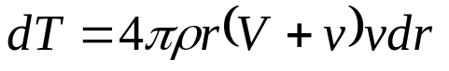
(1)
Next, consider the blade elements that this annulus intersects. The thrust generated by these blade elements is,
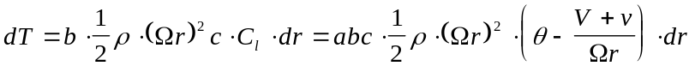
(2)
These two approaches give two estimates for the thrust generated by the annulus of width ‘dr’. Equating these two, we get a quadratic equation for the inflow λ = (V+v)/ΩR:

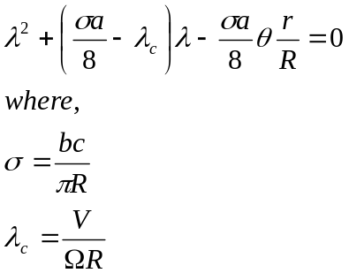
(3)
Note that the chord c and the solidity σ may vary with r/R for tapered rotors. Solving this quadratic equation, we get:

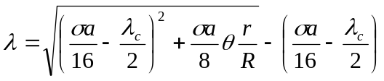
(4)
This equation gives a closed form expression for the induced inflow ratio. Notice that the inflow is no longer uniform! If we know the number of blades, solidity or chord length c, and the lift curve slope a, we can compute the inflow velocity. Once inflow velocity distribution is known, the blade element theory may be used to compute the thrust, and torque in dimensional or non-dimensional form, and the Figure of Merit.
LOSSES NOT ACCOUNTED FOR BY THE COMBINED BLADE ELEMENT-MOMENTUM THEORY
The combined blade element - momentum theory is an improvement over previous theories, al though it has the ad hoc assumption that each annulus behaves independently of the neighbor rings. It does not model two sources of losses, that must be addressed before it may be used in practical calculations.
Tip Loss: The blade element-momentum theory assumes that all the elements of the blade, including those at the very tip produce lift. In reality, there is flow around the blade tip from the lower side to the upper side, which produces a loss in lift in the tip region. Prandtl suggested that this loss be accounted for by performing the integral for thrust only up to r/R = B . beyond this radial location no lift is produced. The elements beyond this location contribute to drag, and profile power, however. He suggested the following expression for B:
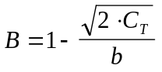
In many instances, B can be simply taken to be 0.97.
Let us see how this tip loss factor affects the estimates for thrust and power in hover, and Figure of Merit, when the simple blade element theory is used. In this case, we can show that C_{T} is reduced from the momentum theory by the factor B². For uniform inflow, the induced power C_{Q} is given by 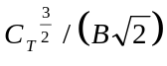.
Thus, the Figure of Merit (neglecting profile power) will be B, or 0.97. Thus, tip losses account for about 3% of the losses. Experiments show that the actual losses are around 15% (Recall κ=1.15 in the empirically corrected expression for the torque coefficient.) these additional losses are thus caused by the non-uniform inflow at the rotor disk, which translates into non-uniform velocity at in the far wake, and swirl.
Swirl: Swirl is caused by the forces (tangential to the plane of rotation) exerted by the rotor on the fluid. There are two types of tangential forces. The first caused by viscous drag, which causes the fluid particles to follow the blade as is the case for the wake behind a truck following the truck. The kinetic energy imparted to the fluid for this useless swirling motion is already accounted for in the profile power estimates, since C_{d} includes both skin friction drag and form drag.
The second tangential force is simply induced drag, which is caused by the rotation of the lift vector by the inflow angle φ. This also causes the fluid particles to follow the blade and swirl. The fluid particles thus follow a spiral trajectory as they spin and descend. Swirl accounts for only about 1% of the total power. It may be crudely estimated as follows.
We consider a fluid particle that descends through the rotor disk. In an coordinate system attached to the blade, the particle will have an angular velocity Ω as it approaches the rotor disk. Underneath the rotor disk, the same particle will only have an angular velocity (Ω−ω), where ω is the angular velocity associated with swirl. Then, from Bernoulli equation in this rotating coordinate system,
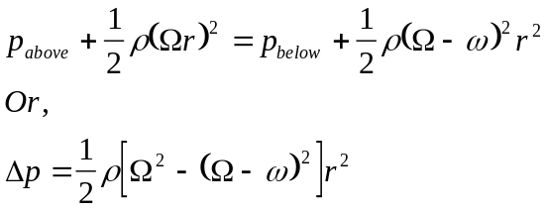
The above equation relates the pressure jump across an annulus of the rotor disk with the swirl underneath that annulus disk. The thrust produced by this annulus disk, according to the momentum theory is Δp. ΔA= 2ρ (v) v DA. Thus,
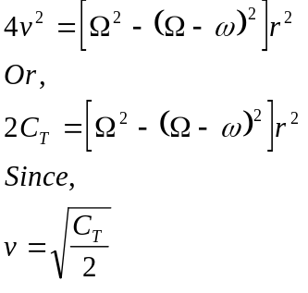
Solving for ω, we get
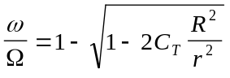
The above expression may be used to find the magnitude of the swirl velocity and direction when required.
The power dumped into the wake associated with this swirl velocity is given by the integral:
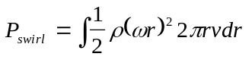
Here the lower limit of the integral is set to r/R= 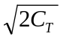 . This integral can be numerically computed for any given thrust coefficient C_{T}.
Swirl accounts for only 1% to 2% of the total power. The present treatment is adequate for estimating these small losses.

